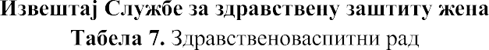
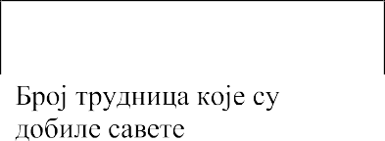

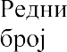 | *
1.
2.
3.
4.
5.
6. | **
*
.
**
.

7

